Amazon creates ip with 172 series. When we create it is 10 series?

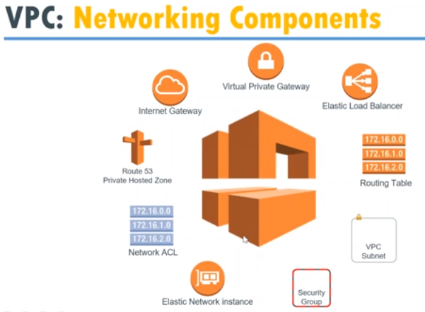

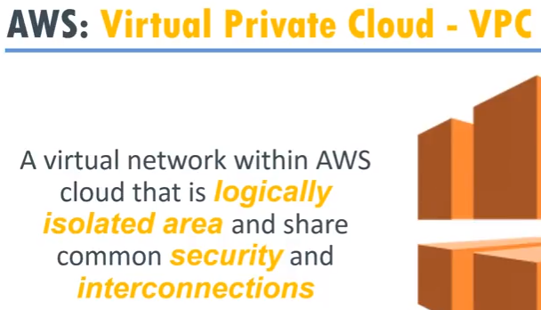

VPC is isolated, by default, two VPCs can’t communicate with each other. We need to enable them